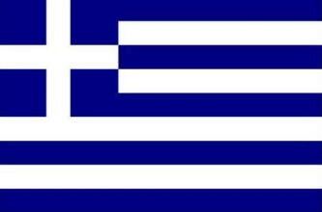 Ms. Maria-Ioanna Verras’s Greek class 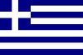
Dear families,
My name is Maria-Ioanna Verras. This school year of 2021-2022 I will be teaching Greek language in Plato Academy Palm Harbor campus. This will be my 5th year of teaching Greek language in Plato Academy Schools and I am more than excited to be in the position of guiding my students in exploring a very rich language deriving from a country that has an astounding historical, philosophical and cultural background which has influenced and still influences the global way of thinking.
As regards to myself, after my birth in Tampa, Florida, U.S.A, I had the chance to follow my family to Athens, Greece where I resided for 24 years. During my long term residence in Greece, I learned 3 languages (Greek, English and French) and graduated with honors from Moraitis School. One year later, I continued with my studies in the National and Kapodistrian University of Athens where I studied psychology and graduated with honors as well. In addition, I completed my internship as a psychologist in an educational school of special needs. After my graduation from the National and Kapodistrian University of Athens and my completion of internship, I came back to Florida, U.S.A and joined the Plato Academy family that has given me a great opportunity to share all this knowledge of Greek language and culture I acquired during my studies directly with my students.
The Greek language course has clear expectations for the students. In 1st Grade, participation counts 100% of the total grading (100%). In order to earn the total grading percentage, students have to follow the Greek teacher’s instructions accordingly and be consistent in completing and returning their Greek work.
This school year, as I have strived to do during my past years of teaching, I am tremendously determined to assist my students in reaching their full potential and achieving their academic goals in terms of consistent collaboration, aspiring challenge and respect. By studying Greek language and culture, students will have a unique chance to discover truths of significant importance that are written in Greek language and are highly empowered to contribute to their willingness to conduct a successful life afterwards. Thus, I am looking forward to a joyful and productive school year full of knowledge acquisition that can build great academic achievements and successes.
Sincerely,
Ms. Maria-Ioanna Verras
Contact me: verrasm@platoacademy.net

